**Training**

1. **Pseudo-code**

// Start of the training

for i=0 to 900

// FIELD’S PART --------

// receive players’ initial positions

MPI_Recv(&initial_players_positions[], 2, MPI_INT, p+1, 0, MPI_COMM_WORLD, MPI_STATUS_IGNORE);

// send current ball position to players

MPI_Send(ball_position, 2, MPI_INT, p+1, 0, MPI_COMM_WORLD);

// PLAYERS’ PART --------

// send my position to the field

MPI_Send(my_position, 2, MPI_INT, 0, 0, MPI_COMM_WORLD);

// receive the ball position

MPI_Recv(ball_position, 2, MPI_INT, 0, 0, MPI_COMM_WORLD, MPI_STATUS_IGNORE);

for j=0 to NUM_STEPS (10 steps overall)

// FIELD’S PART --------

// receive indices of players that reached the ball during a round

MPI_Recv(&playersReachedBall[p-1], 1, MPI_C_BOOL, p, 0, MPI_COMM_WORLD, MPI_STATUS_IGNORE);

// choose a winner if there are a several players reached the ball simultaneously

winnerIndex = who_is_winner(playersReachedBall ,numOfPlayers); // if '-1', there is no winner

// send the winner index to each player so they can detect who won the ball

MPI_Send(&winner, 1, MPI_C_BOOL, p+1, 0, MPI_COMM_WORLD);

// since the field knows the winner index, it receives a new position of the ball right from

// that player

MPI_Recv(new_ball_position, 2, MPI_INT, winnerIndex+1, 0, MPI_COMM_WORLD, MPI_STATUS_IGNORE);

// receive all the data that should go to output after each round: total number of meters

// each player ran, times each of them reached the ball, times each of them won the ball,

// new players positions

MPI_Recv(&players_meters[p], 1, MPI_INT, p+1, 0, MPI_COMM_WORLD, MPI_STATUS_IGNORE);

MPI_Recv(&times_reached_ball[p], 1, MPI_INT, p+1, 0, MPI_COMM_WORLD, MPI_STATUS_IGNORE);

MPI_Recv(&times_won_ball[p], 1, MPI_INT, p+1, 0, MPI_COMM_WORLD, MPI_STATUS_IGNORE);

MPI_Recv(&players_positions[p*2], 2, MPI_INT, p+1, 0, MPI_COMM_WORLD, MPI_STATUS_IGNORE);

// PLAYERS’ PART --------

// if I reached the ball, increase total number of meters I ran

if ((gotBall = did_reach_ball(my_position, ball_position))) {

timesReachedBall++;

}

// Send the data showing wether I got the ball in this round or not

MPI_Send(&gotBall, 1, MPI_C_BOOL, 0, 0, MPI_COMM_WORLD);

// receive the winner index

MPI_Recv(&winner, 1, MPI_C_BOOL, 0, 0, MPI_COMM_WORLD, MPI_STATUS_IGNORE);

// if I’m a winner, I kick the ball and send a new ball position to the field

if (winner) {

kick_ball(ball_position, new_ball_position);

MPI_Send(new_ball_position, 2, MPI_INT, 0, 0, MPI_COMM_WORLD);

}

// send all the data that should go to output after each round: total number of meters

// I ran, times I reached the ball, times I won the ball,

// my new position

MPI_Send(&metersTotal, 1, MPI_INT, 0, 0, MPI_COMM_WORLD);

MPI_Send(&timesReachedBall, 1, MPI_INT, 0, 0, MPI_COMM_WORLD);

MPI_Send(&timesWonBall, 1, MPI_INT, 0, 0, MPI_COMM_WORLD);

MPI_Send(my_position, 2, MPI_INT, 0, 0, MPI_COMM_WORLD);

}

} // End of the game

1. **Communication diagram**

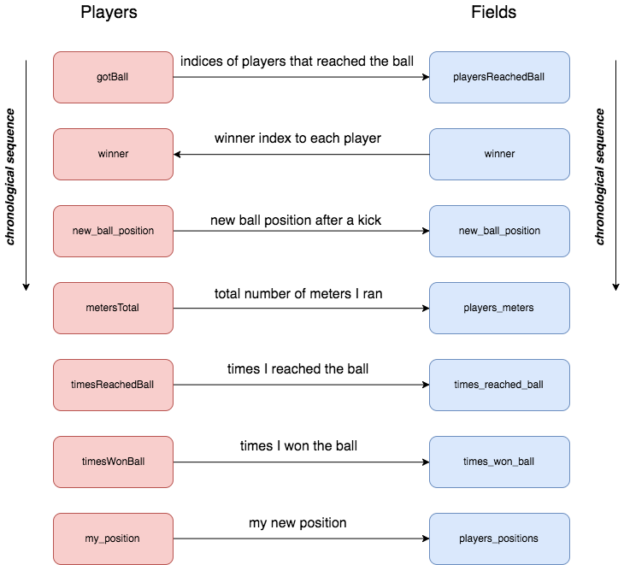

**Match**

1. **Pseudo-code**

// initializing 4 communicators (teamAF and teamBF – communicators for teamA and fields and // teamB and fields respectively)

MPI_Comm_create(teamA);

MPI_Comm_create(teamB);

MPI_Comm_create(teamAF);

MPI_Comm_create(teamBF);

// each process is assigned three parameters on a random basis

assign_skills(speed, dribbling, kickPower, rank)

// each field is assigned with its borders on a football field

assign_borders(myBorders, rank)

// Start of the game

// two halves of the game time

for j=0 to 1 {

//each player is assigned with the position on a football field - each team starts on its //own half of the field

assign_position(myPosition, myFieldSector, rankA, checkTeam, j);

// the ball is positioned at the center

ballPosition[0] = ROW_BALL_INIT_POS;

ballPosition[1] = COL_BALL_INIT_POS;

//2700 rounds in each half

for i=0 to 2700 {

// fields gather initial positions of players in order to output this info in console;

// two different communicators are used for getting positions from both teams;

// thereafter we use both communicators so as to collect/broadcast info from/to

// players of different teams (they are shortened to A/B);

// instead of using both

// MPI_Gather(myPosition, 2, MPI_INT, initialPlayersPositionsA, 2, MPI_INT, NUM_Players, teamAandFields_COMM);

// MPI_Gather(myPosition, 2, MPI_INT, initialPlayersPositionsB, 2, MPI_INT, NUM_Players, teamBandFields_COMM);

// the shortened version is written

MPI_Gather(myPosition, 2, MPI_INT, initialPlayersPositionsA/B, 2, MPI_INT, NUM_Players, teamA/BandFields_COMM);

// knowing a ball position, each field checks if the ball is in its borders;

// IGotBall then is used by players of both teams to get the rank of the process

// possessing the ball

IGotBall = is_ball_in_my_borders(myBorders, ballPosition);

// players collect info on who possesses the ball into ballPossessionIndex array

MPI_Allgather(&IGotBall, 1, MPI_C_BOOL, ballPossessionIndex, 1, MPI_C_BOOL, teamA/BandFields_COMM);

// players receive the rank of a field with the ball using info in

// ballPossessionIndex

fieldWithBallIndex = get_field_index_with_ball(ballPossessionIndex);

// having 'fieldWithBallIndex' received, players know who they collect info on

// 'ballPosition' from;

// thus, players receive 'ballPosition'

MPI_Bcast(ballPosition, 2, MPI_INT, fieldWithBallIndex, teamA/BandFields_COMM);

// FP0 (NUM_Players) collect players' positions in order to broadcast it afterwards to players

MPI_Gather(myPosition, 2, MPI_INT, allPlayersPositions_A/B, 2, MPI_INT, NUM_Players, teamA/BandFields_COMM);

// players collect positions of teammates from FP0 (NUM_Players)

MPI_Bcast(allPlayersPositions_A/B, 2, MPI_INT, NUM_Players, teamA/BandFields_COMM);

// players take decision on what they do next - move or stay on the field till the next round

make_step(myPosition, myFieldSector, speed, ballPosition);

// FP0 collects positions of all players in 'allPlayersPositionsA/B' arrays, so it can choose a

// winner

MPI_Gather(myPosition, 2, MPI_INT, allPlayersPositions_A/B, 2, MPI_INT, NUM_Players, teamA/BandFields_COMM);

// each player calculates a ballChallenge; the value will be used in future in case the player // competes with an opponent

ballChallenge = ((rand() % 10) + 1) * dribbling;

// FP0 gathers all the ballChallenges of players

MPI_Gather(&ballChallenge, 1, MPI_INT, ballChallengeA/B, 1, MPI_INT, NUM_Players, teamA/BandFields_COMM);

// FP0 identifies the index and the team of a winner

identify_winner(allPlayersPositions_A, allPlayersPositions_B, ballPosition, winner, reachedBall_A, reachedBall_B);

// if there are two competitors for the ball, the winner is being chosen on a random basis

choose_winner(ballChallengeA, ballChallengeB, winner, wonBall_A, wonBall_B);

// send 'winners' arrays so that each player can detect if he is a winner

MPI_Bcast(winner, NUM_Players, MPI_C_BOOL, NUM_Players, teamA/BandFields_COMM);

// if a player wins the ball, he kick it to a certain position according to the strategy

if ((didWinBall = did_win_ball(winner, rankA, checkTeam)))

kick_ball(ballPosition, myPosition, myFieldSector, allPlayersPositions_A, goalXcoord, newBallPosition, kickPower);

// FP0 receives new ball position (or a previous position if there were no winners) and sends // it to players

MPI_Gather(newBallPosition, 2, MPI_INT, newBallPositionsA/B, 2, MPI_INT, NUM_Players, teamA/BandFields_COMM);

MPI_Bcast(ballPosition, 2, MPI_INT, NUM_Players * 2, MPI_COMM_WORLD);

} // end of a round

} // end of the game

1. **Communication diagram**

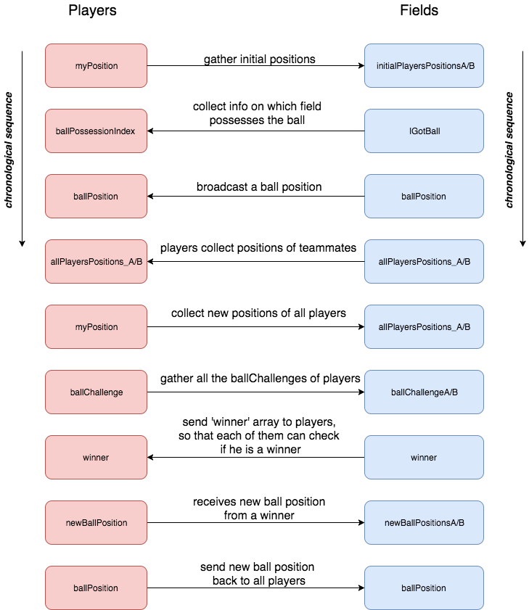

1. **Walkthrough**

**Players positions and strategy**

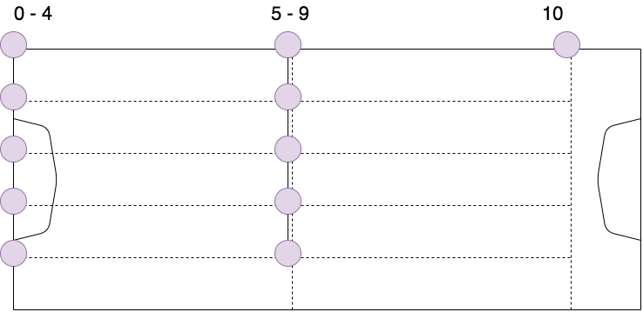

The example scheme from above illustrates initial positions of players of Team A in a first half, which seeks to score a goal at the right goalpost. Players are marked with purple circles. Each player is only allowed to move inside its borders - dash lines, it prevents a game from being a mess since each player takes only its own space. Once a player got the ball, his strategy would be as follows:

* calculate the distance to a goalpost
* calculate the distances to all teammates between me and a goalpost
* if there are some players that are closer to me than a goalpost – choose the closest one and give him a pass (it might take several kicks as the kick distance is restricted by rules); if the goalpost is closer to you than any of your teammates, kick the ball towards the goalpost

In the next half of the game, the initial positions and a target goalpost will be symmetrically reflected. The same is for Team B.